**SYNOPSIS:-**

**Title: Online Examination System**

**Objective**: This project is aimed at developing an online examination system for introduction to

management for students and lecturers. The purpose of the system is to completely automate the old manual procedure of conducting exams to a computerized System. I will provide a more efficient examination system.

The system will allow students to register and take the exam. It also enables lecturers to perform many tasks. The system has several functions. The users will do the registration before using the system. The lecturers can upload questions and answers; he can view the list of all students who take the exam. He can view the list of students who have grade A, grade B, grade C, grade D and those who fail the exam. The lecturers can send emails. Once logging in, the students can choose the subject and take the exam. After finishing using the software, the users have a logout function that allows them to sign out. This is because the system wants to ensure no external users can exploit the system.

**TECHNICAL CONTRIBUTION:**

**1. Hardware Requirement:**

o CPU: Intel Pentium (Dual Core) and above

o Memory: 2 GB RAM

o Internal: 60 GB

**2. Software Requirement:**

o Windows 7 Professional (32 bit) and above.

o Development Language: Python, JavaScript, CSS, HTML

o Database: SQLite

o Server: Apache (XAMPP)

**Dataset**: Our dataset will likely consist of tables in Our SQLite database, such as:

- users (id, username, password, role)

- exams (id, title, description, date, time, duration)

- questions (id, exam_id, question_text, option_a, option_b, option_c, option_d, correct_answer)

- answers (id, user_id, question_id, response)

- results (id, user_id, exam_id, score, grade, feedback)

- courses (id, name, description)

**Methodology**:

1. **Requirements Gathering:** Collect requirements from stakeholders, identifying the features and functionality needed for the system.
2. **Database Design:** Design the database schema, creating tables for users, exams, questions, answers, results, and courses.
3. **Backend Development:** Write Python code to create the backend logic, using a framework like Flask or Django, to handle requests, interact with the database, and generate responses.
4. **Frontend Development:** Write JavaScript, CSS, and HTML code to create the user interface, using a framework like React or Angular, to display exam questions, accept user input, and display results.
5. **API Integration:** Create RESTful APIs to facilitate communication between the frontend and backend.
6. **Testing:** Perform unit testing, integration testing, and UI testing to ensure the system functions as expected.
7. **Deployment:** Deploy the system on the Apache (XAMPP) server, configuring the environment and ensuring scalability.
8. **Maintenance:** Regularly update, fix bugs, and enhance the system based on user feedback and changing requirements.

**Expected Outcome**: The expected outcome of Our Online Examination System project is a fully functional web application that:

**1**. **Securely manages user accounts:** Students, teachers, and administrators can register, login, and access their respective dashboards.

**2.** **Creates and manages exams:** Teachers can create, edit, and delete exams, adding questions and setting exam settings.

**3.** **Delivers exams to students:** Students can access exams, answer questions, and submit their responses.

**4.** **Automates grading and feedback:** The system grades answers, provides feedback, and displays results to students.

**5.** **Generates reports and analytics:** Teachers and administrators can view exam statistics, student performance, and progress reports.

**Abstract**

This project develops a web-based Online Examination System (OES) using Python, JavaScript, CSS, HTML, and SQLite. OES aims to streamline the examination process, enhancing the learning experience for students and simplifying administrative tasks for teachers and administrators. The system securely manages user accounts, creates and manages exams, delivers exams to students, automates grading and feedback, and generates reports and analytics. With a user-friendly interface, scalability, and data security, OES provides a robust and efficient examination platform for academic institutions.

**Keywords:** Online Examination System, Web Application, Python, JavaScript, SQLite, Education, Assessment.

**Gantt Chart**

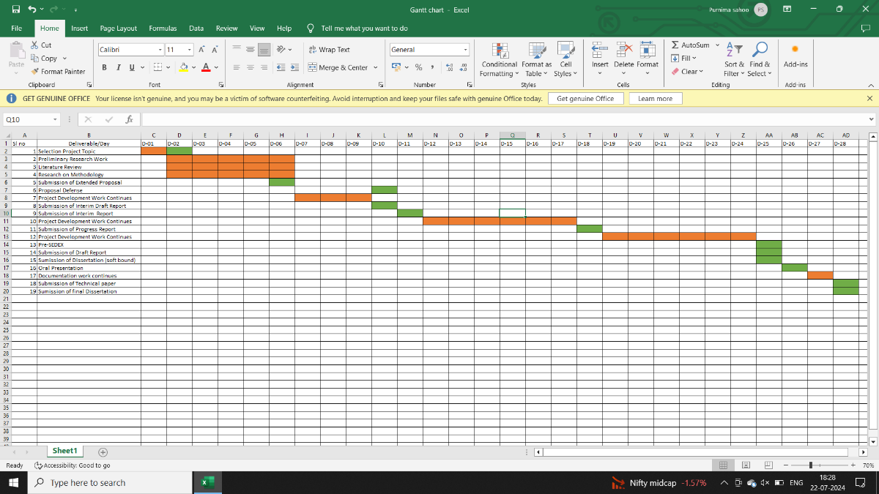

Given the updated timeline from 13 July to 9 August, the project tasks will need to be further condensed. Here's a revised Gantt chart to fit within this shorter timeframe:

Project Timeline: Online Examination System(13 July - 09 August)

**Week 1:**

- Day 1-7: Project topic selection, preliminary research, literature review, research on methodology

- Task: Project topic selection, research methodology

- Deliverable: Extended proposal

**Week 2:**

- Day 8-14: Project development work, intern draft report preparation

- Task: Project development work, intern draft report preparation

- Deliverable: Intern draft report

**Week 3:**

- Day 15-21: Project development work, project proposal preparation

- Task: Project development work, project proposal preparation

- Deliverable: Project proposal

**Week 4:**

- Day 22-28: Project development work, draft report preparation, oral presentation preparation, technical paper preparation, final dissertation preparation

- Task: Project development work, draft report preparation, oral presentation preparation, technical paper preparation, final dissertation preparation

- Deliverable: Draft report, Technical paper, Final dissertation

Here is a visual representation Gantt chart:

| Week | Task | Deliverable |

|--------|---------------------------------------|----------------------------------------------------------|

| 1 | Project Topic Selection | Extended Proposal |

| 2 | Project Development | Intern Draft Report |

| 3 | Project Development | Project Proposal |

| 4 | Project Development, Doc Work| Draft Report, Technical Paper, Final Dissertation|